Introduction:

Mental health is a prominent aspect of human well-being that affects individuals, communities, and societies as a whole. In recent years, there has been a growing recognition of the importance of mental health in developed countries such as the United States, Europe, and Japan. These nations have prioritized the development of psychology and mental health services to enhance the quality of life for their citizens.

In contrast, countries like Vietnam have traditionally placed more emphasis on economic growth rather than mental health. Over the past 10-20 years, Vietnam has experienced significant economic development and progress, which has led to improvements in various aspects of people's lives. However, mental health has often been overlooked and considered a distant concern.

Nevertheless, as Vietnam's economy continues to grow and its citizens experience an improvement in their overall living standards, there is now a noticeable shift in the country's perspective towards mental health. There is a growing interest in understanding and addressing mental health challenges among the population. This change in attitude reflects an increasing awareness of the importance of mental well-being and its impact on individuals, families, and communities.

In light of these developments, the need for effective mental health therapy and support services has become evident. Healthcare professionals play a crucial role in addressing the mental health needs of individuals, and they require adequate tools and resources to provide effective care. This is where technology, such as chatbots, can play a significant role.

This chatbot aims to assist healthcare professionals in providing mental health therapy and improving the quality of life for individuals. By leveraging the capabilities of artificial intelligence and natural language processing, this chatbot can engage in meaningful conversations, offer support, and provide valuable insights into mental well-being. Additionally, the chatbot can contribute to raising awareness about the importance of mental health and promoting a happier and healthier society.

In the following sections, we will explore the challenges and opportunities surrounding mental health in Vietnam, the role of psychology in understanding and addressing mental health issues, and the potential benefits of incorporating technology, such as chatbots, in mental health care. By examining these aspects, we aim to shed light on the importance of mental health and the potential of innovative solutions in improving the well-being of individuals and society as a whole.

Chapter 2: Methodology:  
 2.1 Important Features:

Pycharm:

PyCharm is a popular integrated development environment (IDE) designed specifically for Python programming. Developed by JetBrains, it offers a range of features to enhance the Python development experience. With its user-friendly interface, PyCharm provides advanced code editing capabilities, including code completion, refactoring tools, and syntax highlighting. It also supports version control integration, allowing developers to manage their code repositories seamlessly. PyCharm's debugging and testing features help identify and resolve issues in the code efficiently. Additionally, it offers virtual environment support, enabling developers to manage project dependencies effectively. Overall, PyCharm is a powerful IDE that simplifies Python development tasks and boosts productivity.

Tkinter

Tkinter is a widely adopted Python library that facilitates the development of graphical user interfaces (GUIs). With Tkinter, developers can create intuitive and visually appealing desktop applications by leveraging its comprehensive set of tools and widgets. Whether it's designing windows, buttons, menus, or handling user interactions, Tkinter offers a simple and intuitive API for building interactive applications.

A notable advantage of Tkinter is its cross-platform compatibility, allowing applications to run seamlessly on various operating systems. This versatility makes Tkinter a reliable choice for developers seeking to reach a broader user base. Moreover, Tkinter's extensibility empowers developers to customize the appearance of widgets, create their own custom widgets, and integrate additional functionalities using third-party libraries.

Huggingface:



Hugging Face is a renowned organization and platform specialized in natural language processing (NLP) and machine learning. They have made significant contributions to the advancement and promotion of NLP models, datasets, and tools.

The Hugging Face platform provides a vast array of resources catered to NLP practitioners and researchers. Notably, they have developed the Transformers library, an open-source library built on PyTorch and TensorFlow. Transformers encompass a collection of pre-trained models, including popular ones such as BERT, GPT, and RoBERTa, which have demonstrated impressive capabilities in various NLP tasks like text classification, language translation, and text generation.

OpenCV

OpenCV (Open Source Computer Vision Library) is a widely-used open-source computer vision and machine learning software library. It provides a comprehensive set of tools and functions for image and video processing, object detection and recognition, and various computer vision tasks.

One of the key strengths of OpenCV is its robust support for real-time computer vision applications. It provides modules for video capturing, video streaming, and video analysis, enabling developers to build applications that process and analyze video streams in real-time. OpenCV also includes pre-trained models and methods for object detection, facial recognition, and tracking, making it valuable for tasks like surveillance, augmented reality, and robotics.

Kaggle:

Kaggle is an online community and platform that provides a collaborative environment for data scientists, machine learning practitioners, and researchers to work on and solve complex data-related challenges. It hosts a wide range of datasets, competitions, and notebooks, allowing users to explore, analyze, and build models on real-world data.

Kaggle also serves as a comprehensive repository of datasets. Users can access and download a vast collection of public datasets, spanning various domains and sizes. This provides a valuable resource for data exploration, model development, and research.

Furthermore, Kaggle offers a cloud-based computational environment known as Kaggle Kernels. Kernels allow users to write and execute code in popular programming languages like Python and R, with built-in support for popular data science libraries. Kernels facilitate collaborative coding, where users can share their code, analysis, and findings with the community.

The Kaggle community is highly active and supportive, fostering collaboration and knowledge sharing. Users can engage in discussion forums, ask questions, and share insights, enabling a vibrant exchange of ideas.

FlowiseAI

FlowiseAI is an open-source low-code/no-code drag and drop tool that allows users to build customized Language Learning Models (LLMs) [[2]](https://www.linkedin.com/company/flowiseai). It provides a user-friendly interface for visualizing and creating LLM apps without requiring extensive coding knowledge. Here is some key information about FlowiseAI:

Features of FlowiseAI:

* Drag & Drop Interface: FlowiseAI offers a visual interface that allows users to easily create workflows by dragging and dropping components [[1]](https://github.com/FlowiseAI/Flowise).
* Customization: Users can customize their LLM apps according to their specific requirements by selecting and configuring different components within the tool [[1]](https://github.com/FlowiseAI/Flowise).
* LangchainJS: FlowiseAI is built using LangchainJS, a Node Typescript/Javascript framework, which makes it accessible to developers and language enthusiasts [[3]](https://medium.com/@adyog/flowiseai-a-low-code-no-code-drag-drop-tool-to-visualize-and-build-llm-apps-23aa09183e7c).
* Free and Open Source: FlowiseAI is an open-source tool, meaning it is available for free and can be used for personal and commercial purposes [[3]](https://medium.com/@adyog/flowiseai-a-low-code-no-code-drag-drop-tool-to-visualize-and-build-llm-apps-23aa09183e7c).
* Docker Support: FlowiseAI supports Docker, allowing users to containerize their language models and simplify deployment across different environments [[3]](https://medium.com/@adyog/flowiseai-a-low-code-no-code-drag-drop-tool-to-visualize-and-build-llm-apps-23aa09183e7c).
* Community Collaboration: FlowiseAI encourages community-driven development and provides channels for users to engage with the FlowiseAI team and fellow developers through Discord, Twitter, and email

2.2 Application description

To fulfill the noble aspirations of creating a transformative psychological chatbot that assists individuals in Vietnam with depression, a methodology was devised using PyCharm and Tkinter. The interface consists of three key components: an intelligent conversational agent powered by PyCharm's natural language processing, a visually appealing GUI designed with Tkinter, and additional features like soothing audio and adaptive responses. Together, these elements aim to provide personalized support and guide individuals towards emotional well-being and renewed joy in life.

* Image Sentiment Analysis:

The proposed approach includes an Image Sentiment Analysis component, which utilizes the huggingface library and specifically the openai/clip-vit-large-patch14 model for detecting emotions based on facial expressions. This model, categorized as an image zero-shot classifier, possesses the ability to classify images with custom labels. To facilitate emotion recognition, a set of carefully selected emotion labels, including Sad, Happy, Neutral, Fear, Anger, Pleasant-Surprise, and Disgust, is incorporated. The process commences with capturing the image using the openCV Python library, after which it undergoes analysis using the aforementioned model, ultimately yielding the dominant emotion along with corresponding percentage probabilities. This integration of image analysis enhances the chatbot's understanding of user emotions, allowing for a more nuanced and empathetic response tailored to the individual's emotional state.

* Voice Sentiment Analysis:

Another crucial component of the system is Voice Sentiment Analysis, which aims to detect emotions based on the tone of the user's voice. This functionality relies on a model trained using a Kaggle dataset, which includes default emotion labels such as Sad, Happy, Neutral, Fear, Anger, and Pleasant-Surprise. The process begins by recording and saving the user's voice at specific intervals. The recorded voice is then analyzed using the trained model, providing the highest detected emotion along with corresponding percentage probabilities. By incorporating Voice Sentiment Analysis, the chatbot becomes capable of understanding and responding to the user's emotional state, enabling it to provide tailored support and guidance based on the detected emotions in the user's voice. This integration adds depth and sensitivity to the chatbot's interactions, fostering a more personalized and empathetic user experience.

* Chatbot Therapy:

+ LLM setup:

In order to establish an effective Language Learning Model (LLM) for the chatbot, FlowiseAI, an open-source tool that simplifies the process by offering a user-friendly drag and drop interface. This tool empowers me to construct a customized LLM model by seamlessly integrating multiple features and functionalities, all with the convenience of low-code or no-code development. Leveraging FlowiseAI, I can define and configure the specific requirements and parameters that will enable the chatbot to engage in meaningful language learning interactions, ensuring an optimized and personalized learning experience for users.

+ Psychology Preparation:

FlowiseAI offers the advantage of OpenAI Embeddings features. These features enable the chatbot to comprehend the main ideas and concepts within various file formats such as CSV, Word, and PDF. Leveraging this capability, I can gather a curated collection of PDF resources covering several key topics in psychology, including Developmental Psychology, Social Psychology, Educational Psychology, Depression Psychology, Anxiety Psychology, and Behavioral Psychology. By understanding these concepts, the chatbot will be equipped to assist patients in comprehending their mental state and guide them on strategies to overcome challenges related to depression, anxiety, and other psychological issues. This integration of comprehensive psychology resources enhances the chatbot's ability to provide valuable insights and support to individuals seeking assistance in their mental well-being journey.

Chapter 3: App background

To create the GUI for your psychology application, you can follow these steps.

To create the GUI for your psychology application, you can follow these steps.

Step 1: Install Tkinter library using the command pip install tkinter. Tkinter is a Python library that allows you to create GUIs easily.

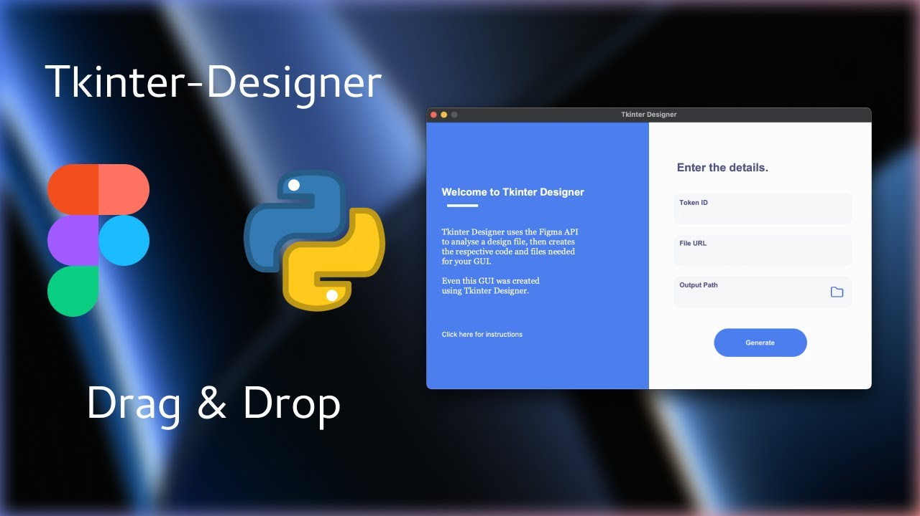

Step 2: Begin by creating the main window of your application. Set the width to 1200 and the height to 800. You can also set a background image for the window to enhance the visual appeal.

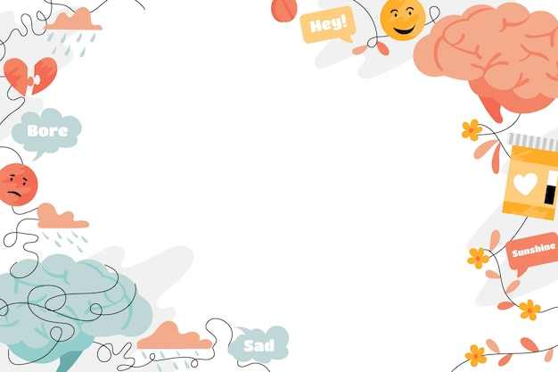

Step 3: Application Diagram Map:

Your psychology application consists of three main parts. The first part is Image Sentiment Classification, where you will classify facial emotions using openCV. This involves analyzing images and determining the emotions expressed by the faces in those images. The second part is Voice Sentiment Classification, where you will record voice samples, play them back, and classify the sentiment expressed in the voice. Lastly, you have the Psychology Chatbot, which serves as a user interface for interacting with the application. The chatbot will guide users through the different functionalities and provide assistance as needed.

By structuring your application in this way, users will be able to explore image sentiment classification, voice sentiment classification, and interact with the psychology chatbot seamlessly. This GUI-based approach will enhance user experience and make your psychology application more accessible and user-friendly.

Chapter 4 : Image Emotion Classification

Hugging Face

Zero-shot image classification:

Zero-shot image classification involves classifying images into different categories using a model that has not been specifically trained on labeled data from those specific categories. Traditional image classification approaches require training models on labeled images, where the models learn to associate visual features with particular labels. However, in zero-shot image classification, models are trained on datasets containing images and accompanying descriptions. Through this training, they acquire aligned vision-language representations, which can be utilized for diverse downstream tasks.

Zero-shot image classification enables models to transfer the knowledge learned during training to classify new classes absent from the training data. This approach functions as a variant of transfer learning, leveraging the model's comprehension of visual and semantic relationships to generalize to unseen classes.

The zero-shot image classification task at hand involves using the model openai/clip-vit-large-patch14, which can accommodate a vast number of parameters with varying labels. For the purpose of this thesis, the specific emotion labels utilized are Sad, Happy, Neutral, Fear, Anger, Pleasant-Surprise, and Disgust.

To use the openai/clip-vit-large-patch14 model, you will need to install the transformers library (which allows you to employ pre-trained models from Hugging Face) and use the provided code snippet:

from transformers import CLIPProcessor, CLIPModel

model = CLIPModel.from_pretrained("openai/clip-vit-large-patch14")

processor = CLIPProcessor.from_pretrained("openai/clip-vit-large-patch14")

Explaining the main idea in the code

Explanation of the code:

'from transformers import CLIPProcessor, CLIPModel': This line imports necessary classes from the Transformers library, specifically the CLIPProcessor and CLIPModel classes.

'model = CLIPModel.from_pretrained("openai/clip-vit-large-patch14")': This line creates an instance of the CLIPModel class by loading the pre-trained CLIP model called "openai/clip-vit-large-patch14." This model, developed by OpenAI, is based on the Vision Transformer (ViT) architecture.

'processor = CLIPProcessor.from_pretrained("openai/clip-vit-large-patch14")': This line creates an instance of the CLIPProcessor class by loading the associated pre-trained processor for the CLIP model. The processor handles tokenization and other preprocessing tasks specific to the CLIP model.

Combining additional technologies such as image capturing using OpenCV and image analysis, the identified emotion with the highest score (expressed as a percentage) is displayed in the top left corner of the frame.

With the combination of Capture Image using Open CV2, analyzing the image and it will the emotion with highest score (in percentage) at the top left of the frame like this figure

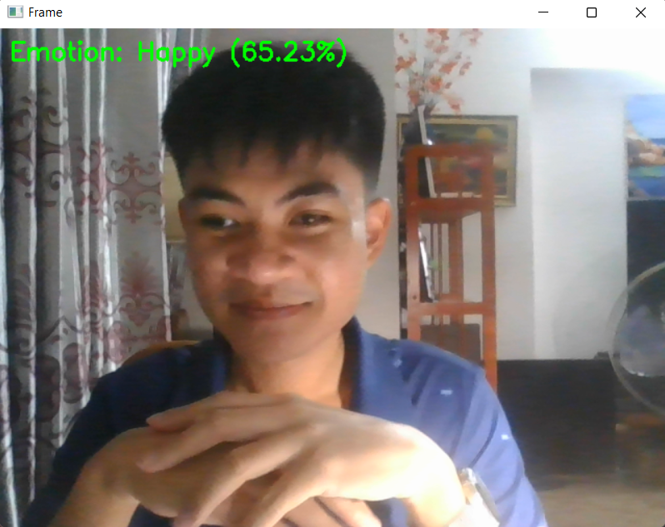

Chapter 5 :Voice Emotion Classification

On the Voice Emotional Field has 3 parts: Recording, Running and Analyzing

Recording: When the recording button is pressed, it will save the video in specific ammount of time then finished

Playing: It will run the lastest audio recorded

Analyzing: This will analyzing the most emotion appear in percentage

In order to analyze the audio, first I get the data about emotional-speech <https://www.kaggle.com/datasets/ejlok1/toronto-emotional-speech-set-tess> (datasets)

Dataset information:

The TESS dataset consists of 2,800 audio samples .

The recordings are performed by two actresses, aged 26 and 64, who speak English as their first language.

The dataset includes seven different emotions: anger, disgust, fear, happiness, pleasant surprise, sadness, and neutral.

Each emotion category contains 400 data samples.

After training and saving as emotion_model.h5 and label_encoder.pkl, It will use for testing.

Chapter 6 : LLM with FlowiseAI

Flowise AI

Navigate to Flowise AI

Explain the flowise model how it work

Chapter 7 : Psychology knowledge preparation

Developmental Psychology,

Social Psychology,

Educational Psychology,

Depression Psychology,

Anxiety Psychology,

Behavioral Psychology.

Chapter 8 : Conclusion